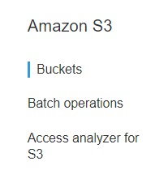

**Step 1:** Create Bucket

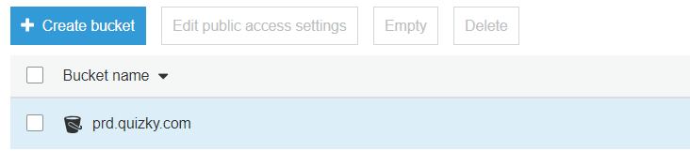

**Step 2:** Click on the bucket and navigate to properties tab and Enable the versioning and Click save.

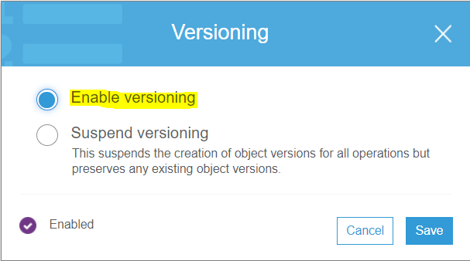

**Step 3:** After enabling the Versioning you can able to see the versions. We can see the versions by click on the show button.

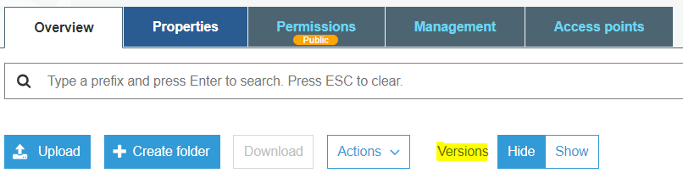

**Step 4:** After enabling the versioning. We can see the versioning option enabled.

